WORK SHEET - 1
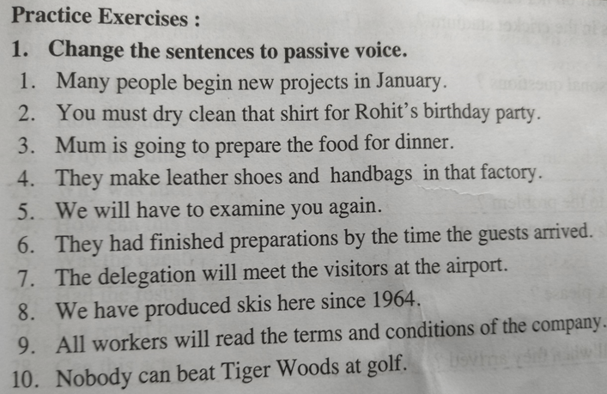
1. New projects are began by many people in January.
2. That shirt must be dry cleaned by you for Rohit’s birthday party.
3. The food is going to be prepared by mum for dinner.
4. Leather shoes and handbags are made by them in that factory.
5. You will have to be examined by us again.
6. Preparations had been finished by them by the time the guests arrived.
7. The visitors will be met by the delegation at the airport.
8. Skis have been produced here by us since 1964.
9. The terms and conditions of the company will be read by all workers.
10.Tiger woods at golf can’t be beaten by anybody.

